Team 1
DATS 6103: Summary Report
Professor Ning Rui
April 30, 2025

Food Deserts in the United States

Introduction
Food deserts are communities where residents have limited access to affordable and nutritious food, particularly fresh fruits and vegetables. These areas are often defined by their lack of supermarkets or grocery stores within convenient traveling distance and typically overlap with low-income or marginalized populations. According to the USDA, food deserts are identified as census tracts meeting both low-income and low-access criteria.
Our project was motivated by the critical public health and social equity implications of food deserts. Millions of Americans—especially those living in rural regions, minority communities, or impoverished neighbourhoods—struggle to access essential nutrition, which may contribute to broader systemic issues including chronic health problems, economic stagnation, and inter-generational poverty. Given the increased awareness of health disparities during the COVID-19 pandemic, we saw an opportunity to use data science tools to provide insights that could support more equitable food systems across the U.S.
This project aimed to use data-driven methods to explore the geographic patterns, contributing factors, and potential policy interventions related to food deserts in the United States. Through exploratory data analysis, statistical modelling, and predictive analytics, our team sought to understand the root causes and potential solutions to this pressing issue.

SMART questions
Food security is a fundamental determinant of health and well-being, and addressing food deserts requires detailed analysis. We were especially interested in exploring how machine learning models could not only reveal trends but also inform actionable policies. So, we set forth the following SMART questions:

- Where are food deserts most geographically concentrated across the U.S., and how do these concentrations differ between urban and rural census tracts?
- What demographics and socioeconomic factors are linked to food deserts?
- How are food deserts related to health issues like obesity and diabetes?
- Can we develop a predictive model that accurately identifies high-risk areas likely to be or become food deserts based on social and economic indicators?
- What national policies could reduce food deserts based on our findings?

Literature Review
Prior research has shown that food deserts are more prevalent in areas with high poverty, low vehicle ownership, and limited access to transportation. Studies have documented the link between food access and diet-related health outcomes, although the strength of this relationship varies by region and demographic group. Some researchers argue that physical proximity to food is only part of the problem—affordability, cultural preferences, and education also play key roles.
For instance, Ver Ploeg et al. (2009) in a USDA report highlighted that while low-income communities often lack large grocery stores, they may still have small corner stores that offer limited or unhealthy food options. Other studies, such as those by Walker et al. (2010), have shown that the presence of food deserts correlates with increased prevalence of obesity and Type 2 diabetes, but access alone does not guarantee improved health outcomes.
Our project builds on these findings by integrating datasets across health, economic, and demographic dimensions to assess both the presence and the effects of food deserts.

Description of the Data
We utilized and downloaded 2 public datasets directly from USDA:
- Food Access Research Atlas: Provides tract-level indicators of food access based on income and distance to supermarkets.
- Food Environment Atlas: Provides supplementary food environment factors—such as store/restaurant proximity, food prices, food and nutrition assistance programs, and community characteristics—interact to influence food choices and diet quality.
We chose LILATracts_1And10 as the proxy variable for Food Desert. This variable sufficiently captures the definition of a food desert as set forth by the USDA.
LILATracts_1And10 is a binary indicator variable (1 = true, 0 = false) that identifies census tracts that meet both of the following criteria:
- Low-Income Tract (LI):
  - The tract's poverty rate is ≥ 20%,
  - or the tract's median family income is ≤ 80% of the state (or metropolitan area) median.

- Low-Access Tract (LA):
  - At least 500 people or 33% of the population in the tract reside more than:
    - 1 mile (urban) or
    - 10 miles (rural)
from the nearest supermarket, supercentre, or large grocery store

The Food Access Atlas had 147 features in total including LILATracts_1And10, and the Food Environment Atlas had a separate table for each cohort like stores, restaurants, access, etc. with a total of 281 features. All tables were joined using CountyFIPS codes to ensure geographic consistency and the combined dataset had 428 features in total. There was a total of around 74k observations in the aggregated data. Since the variable list was large, we needed to implement a robust feature selection process to filter the features for modelling.

Data preprocessing and feature selection
The following steps were employed in sequence to clean the data:
- Dropping columns based on fill-rate: Only variables with a fill rate of >=90% were retained.

- Data imputation: Of the remaining columns, the missing values of numerical variables were imputed with the median of its respective column.

- Data type conversion: The binary columns, including the target variable, were converted to factor type, which would be useful when used with the glm model.

- Data standardization: The numeric columns were standardized using z-score transformation which is helpful for faster convergence during modelling.

- Random sampling: Since there were 74k observations, we needed to subset the dataset to use only a 30% random sample (~22k rows) for model training purposes.

Once the data was adequately cleaned and sub-sampled, we performed the following steps to filter the features:

- Iterative Univariate feature selection: We built a logistic regression model using one variable from the feature list as the independent (X) and FoodDesert as the dependent variable (y). Once all the models were built, only the features wherein the model p-value was statistically significant (<0.05) were selected.

- Penalized Lasso regression: The second step was to perform a lasso penalization on the logit model using all the variables from the previous step. Lasso tends to make the coefficients of the weak variables to zero thereby eliminating them.

- Iterative feature elimination with vif: The features output from the lasso model were then used to build logit model and the corresponding vif scores of the variables were calculated. The feature with the maximum vif score was removed and this modelling process was repeated until the max vif score was <5.

- Iterative feature elimination by p-value: The final step involved filtering the features by the p-value of the coefficients. Since there were about 100 variables at this stage, we put a stringent threshold for the p-value (<0.01) to make sure only the strongest factors affecting FoodDesert were retained.
At the end of the feature selection process, there were a total of 27 variables which were strongly linked to FoodDesert.

Exploratory Data Analysis (EDA)
We began our EDA by focusing on the key variables associated with food access and socioeconomic hardship, rather than external health data or spatial mapping.

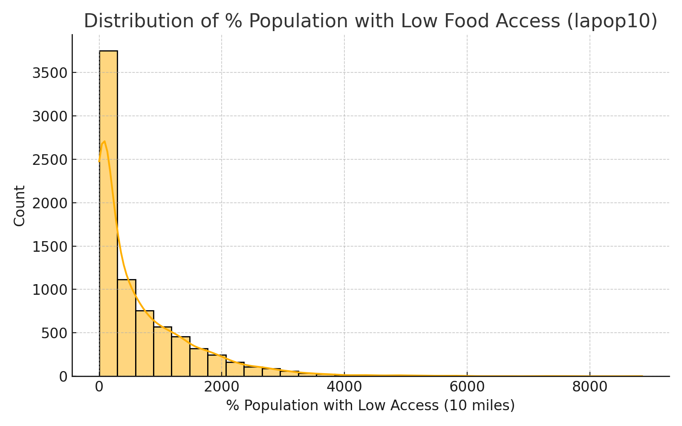

Distribution Analysis:
The primary variable of interest, lapop10 — the percentage of the population in a tract with low access to food within 10 miles — showed a positively skewed distribution. This indicates that while most tracts have relatively low percentages of food inaccessibility, a minority of tracts experience significantly higher rates, marking them as potential food deserts.
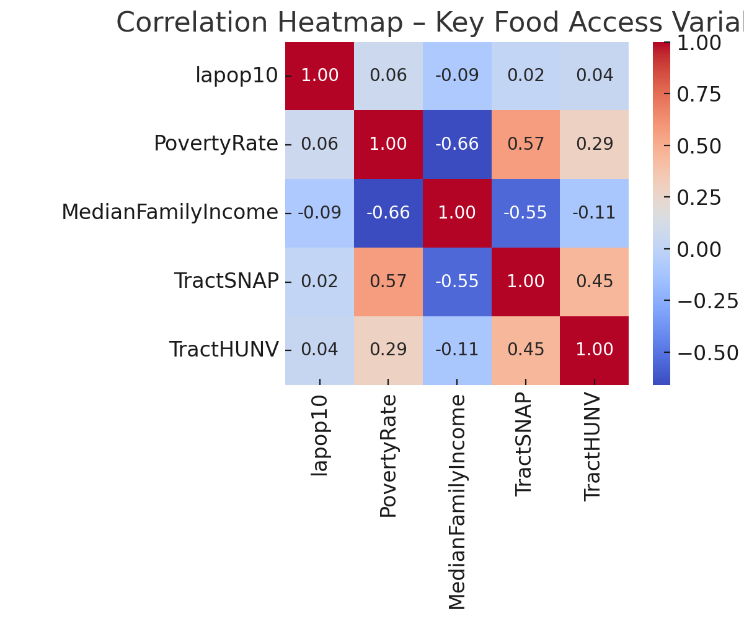

Correlation Analysis:
We explored the relationships between lapop10 and other core variables including:
- PovertyRate
- MedianFamilyIncome
- TractSNAP
- TractHUNV
A correlation heatmap revealed strong positive associations between food inaccessibility and poverty and SNAP participation. Conversely, MedianFamilyIncome showed a negative correlation with lapop10, reinforcing the expected link between low income and poor food access. Lack of vehicle ownership (TractHUNV) was also positively correlated, highlighting transportation as a key access barrier.

SMART Questions & Insights
Q1: Where are food deserts most geographically concentrated across the U.S.?
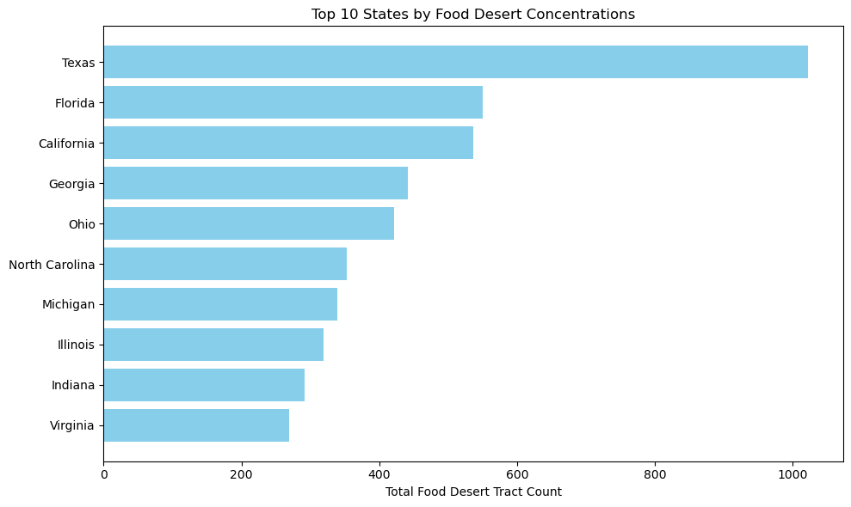

We used tract-level USDA data to identify hotspots of food insecurity. As mentioned, southeastern and southwestern states have the greatest concentrations, with rural tracts generally more affected in terms of physical access and urban tracts more affected in terms of density.
This spatial distribution is likely influenced by factors such as:
- Urban sprawl and zoning in cities
- Lack of commercial incentives in rural markets
- Poor infrastructure and limited transportation
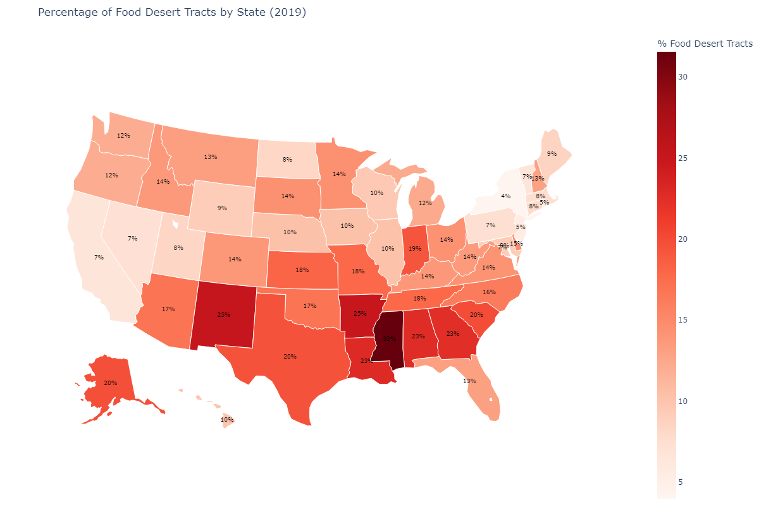

Q2: What demographics and socioeconomic factors are linked to food deserts?
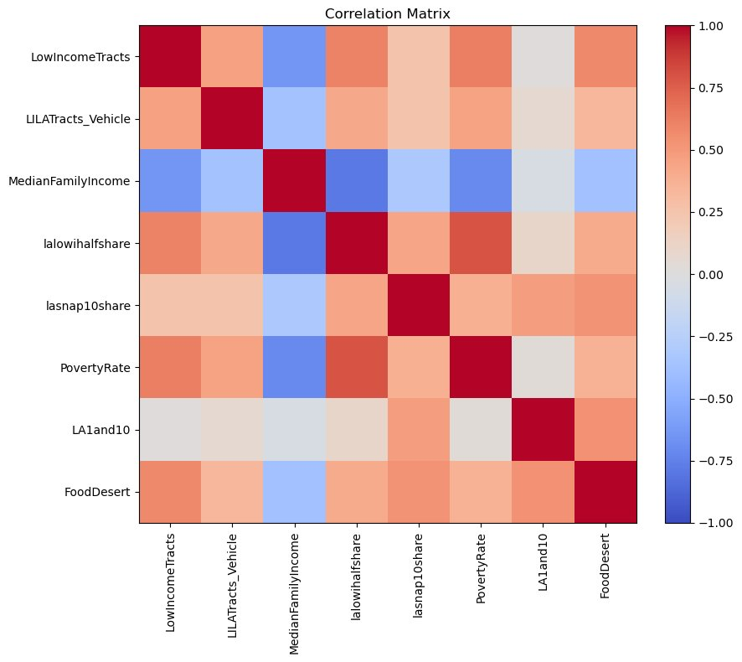
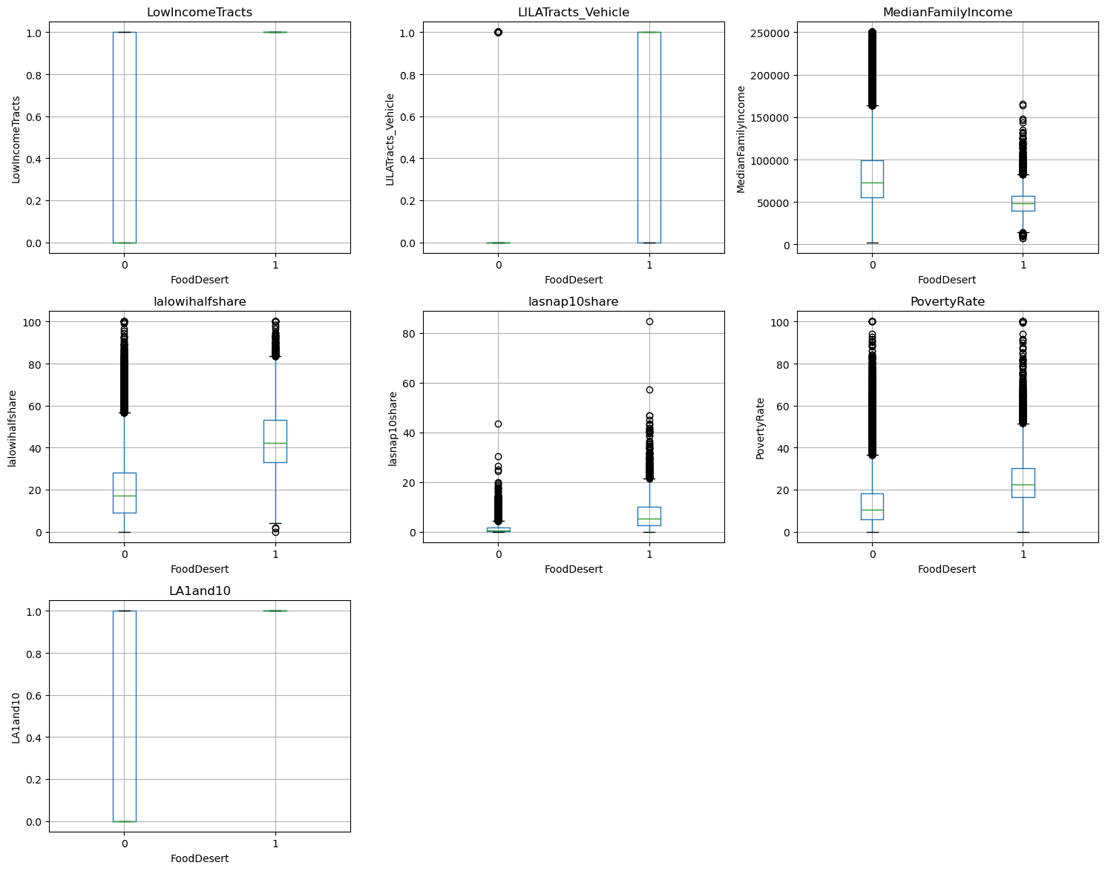
Key variables associated with food deserts include:
- Low income status
- Limited vehicle access
- High unemployment
- High SNAP dependency
- Lower educational attainment
These indicators suggest that food insecurity stems from structural inequality, not just poor planning. Households may technically live within a mile of a grocery store, but without a car or reliable public transport, access remains a barrier.

Q3: How are food deserts related to health issues like obesity and diabetes?
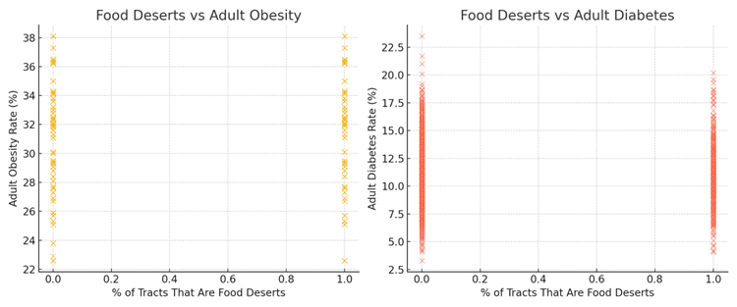

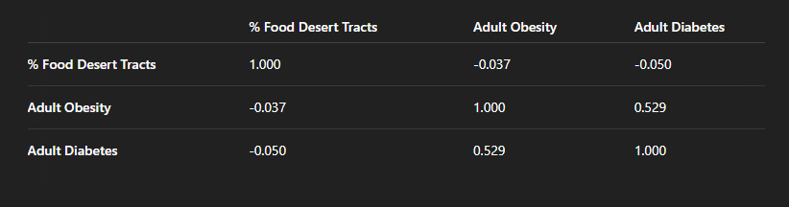
We merged tract-level health data with food desert indicators. Our analysis found:
- A weak correlation between food desert status and obesity/diabetes rates
- A strong correlation (r ≈ 0.53) between obesity and diabetes themselves
[Insert visual: Health outcome correlation table]
This suggests that food deserts may contribute to poor health, but they are not the sole driver. Other influences—such as healthcare access, exercise opportunities, cultural diet patterns, and education—must also be considered.

Q4: Can we develop a predictive model that identifies high-risk areas?
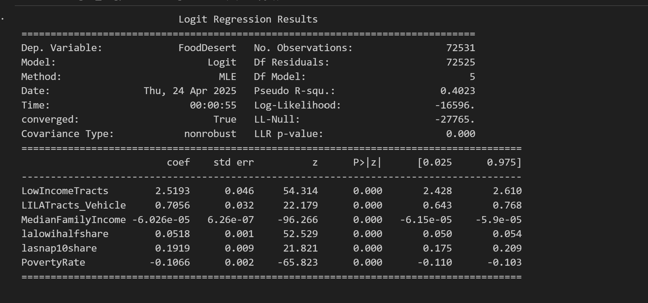

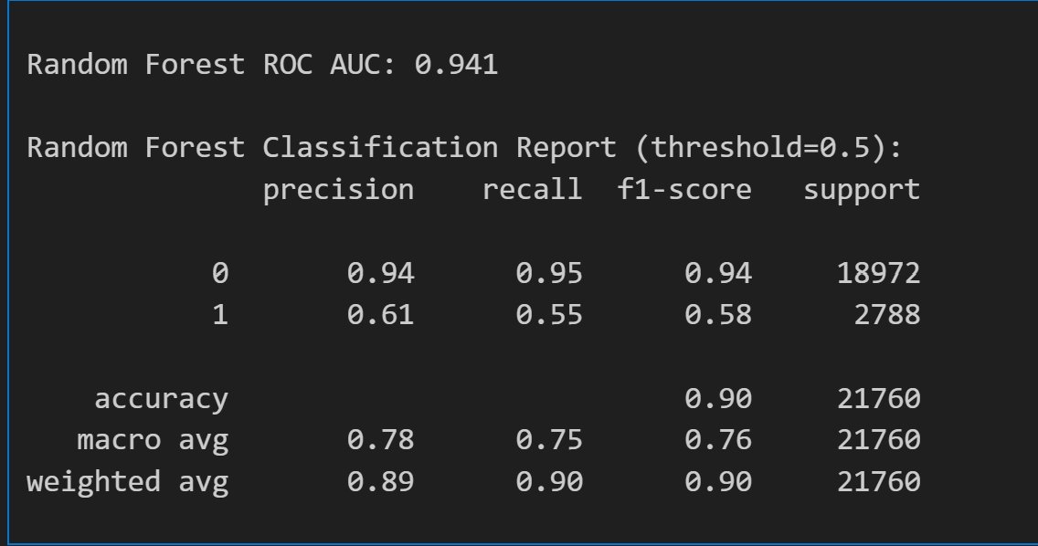
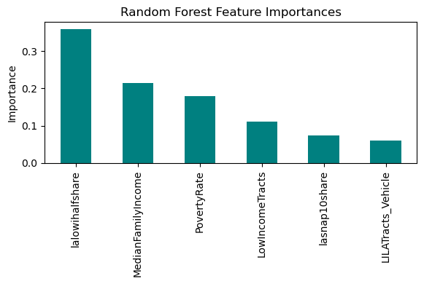

We constructed two predictive models:
- Logistic Regression – Provided interpretable coefficients for each variable.
- Random Forest – Offered higher performance and ranked feature importance.
Logistic Regression Highlights:
- Poverty rate, SNAP participation, and low vehicle access were statistically significant.
- Model accuracy was moderate, but interpretability was strong.
Random Forest Metrics:
- Higher accuracy and AUC.
- Top features included:
  - SNAP Participation
  - Poverty Rate
  - Vehicle Access
  - Median Family Income
[Insert visuals: Logit summary and RF feature importance from slides]
The models performed well in classifying food desert tracts and could be adapted by policymakers to target at-risk areas more proactively.

Q5: What national policies could reduce food deserts?

Our results point to multiple intervention opportunities:
- SNAP expansion: Increase funding, broaden eligibility, and promote acceptance at more retail locations.
- Transportation improvements: Invest in public transit and infrastructure in low-access areas.
- Incentives for local grocers: Offer tax breaks or subsidies to encourage stores to open in underserved communities.
- Nutrition education programs: Combine access initiatives with awareness campaigns.
- Support for local agriculture: Encourage farmers’ markets and community-supported agriculture in urban and rural areas.
These interventions should be multi-tiered, combining federal, state, and local efforts and tailored to regional needs.

Conclusions
Our analysis confirms that food deserts are complex, multifactorial problems rooted in geography, infrastructure, and inequality. While physical distance to food sources matters, our findings emphasize that income, transportation, and economic vulnerability are stronger predictors of food insecurity.
Health impacts are not directly caused by food deserts alone, but they are amplified by the intersecting disadvantages that accompany them. Thus, any solution must address the full ecosystem—access, affordability, education, and opportunity.
Our predictive models offer a foundation for targeted policy responses and further research. By identifying high-risk areas with precision, we can improve resource allocation and advance equitable access to nutrition for all Americans.

Limitations and Future Directions
Some limitations of our study include:
- Health data was at the county level, while food desert classification was tract-level, leading to some granularity mismatch.
- Not all relevant variables were available—future research should integrate factors like crime rates, school quality, and walkability.
- Our models assume static conditions; longitudinal data could better capture the dynamics of changing neighbourhoods.
Future directions include:
- Incorporating geospatial clustering and time-series analysis.
- Analyzing interventions and their outcomes over time.
- Collaborating with urban planners, public health departments, and non-profits for real-world applications.

References

1. Ver Ploeg et al. (2009).
Access to affordable and nutritious food: Measuring and understanding food deserts and their consequences: Report to Congress.
U.S. Department of Agriculture, Economic Research Service.
https://www.ers.usda.gov/publications/pub-details/?pubid=42729

2. Walker, R. E., Keane, C. R., & Burke, J. G. (2010).
Disparities and access to healthy food in the United States: A review of food deserts literature. Health & Place, 16(5), 876–884.
https://doi.org/10.1016/j.healthplace.2010.04.013

